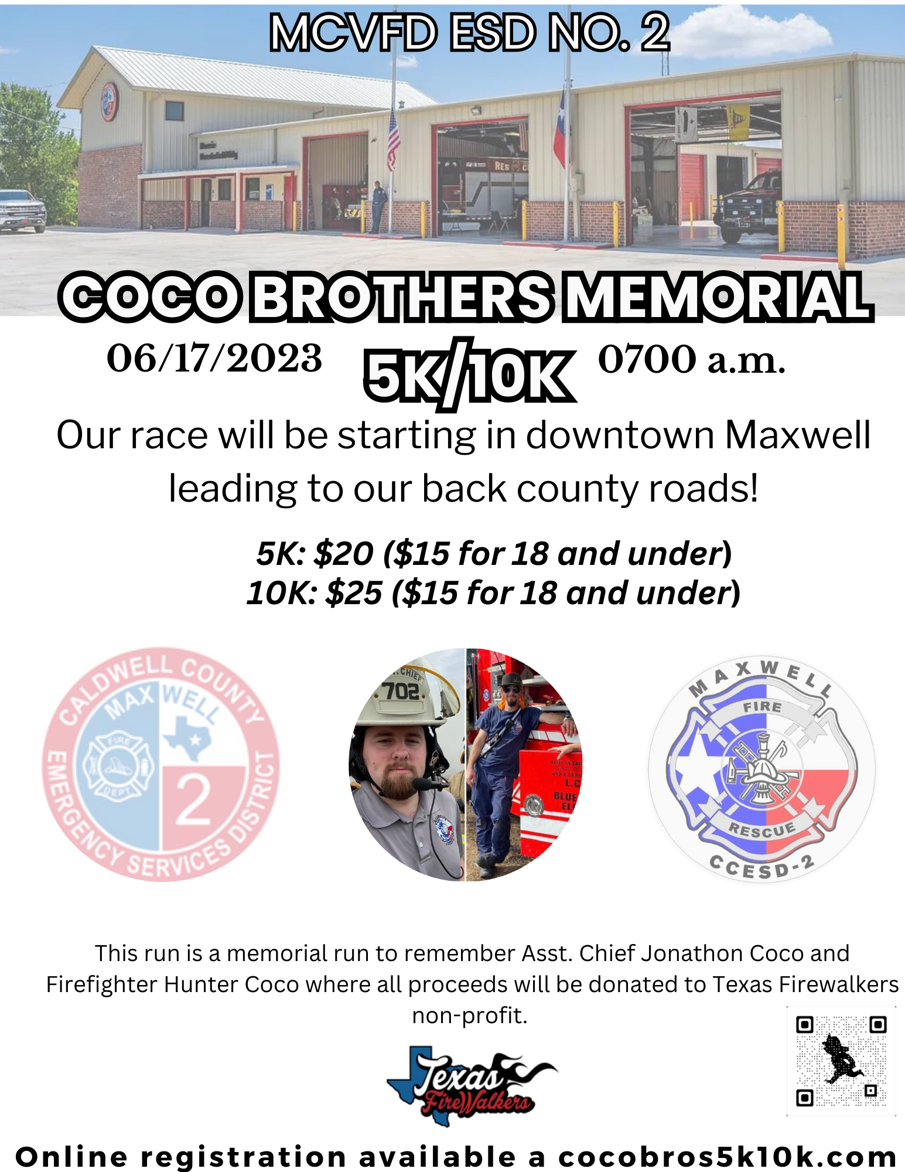
https://www.athleteguild.com/event/maxwell-tx/2023-mcvfd-coco-brothers-memorial-5k10k
We are excited to be planning our first annual Coco Brothers Memorial 5K/10K for June 17, 2023! We will start our race in Downtown Maxwell leading into our back country county roads– proceeds will go towards benefitting Texas Firewalkers non-profit charitable organization. We are hoping to celebrate the lives of both Assistant Chief Jonathon Coco and Firefighter Hunter Coco while raising money for a good cause.

Who are Texas Firewalkers?

Texas Firewalkers are a non-profit, 501( c )(3) charitable organization that aids families displaced by residential fire, supports First Responder incidents and provides hot meals to communities effected by natural disasters across Texas. Texas Firewalkers has also created a safety network to provide a disaster deployment response that is funded completely by donations and their annual events.

Why are they special to MCVFD ESD No. 2 and our community?

After the incident our fire family had a tough time navigating such a great loss. Texas Firewalkers came in and provided hot meals to not only our volunteer fire department but the whole community that attended the service for our boys. They cooked, served and cleaned up after themselves without asking for anything in return. After the event, they also donated our first set of memorial challenge coins (via Dutycoin.com) where we in turn sold them in order to provide relief for the families the boys left behind. Our hope is that the funds we raise will benefit Texas Firewalkers so they can continue to provide such valuable assistance to those that need it.

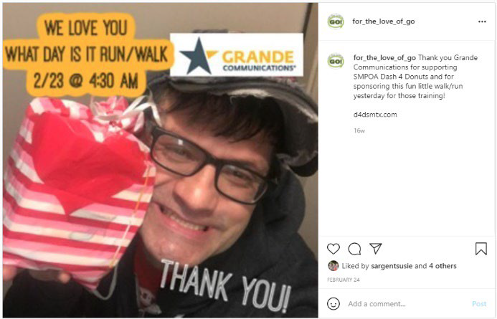
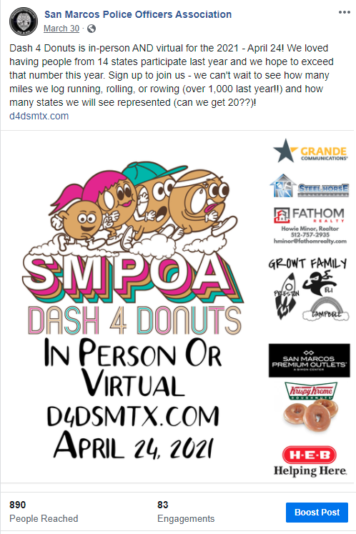
Maxwell Community Volunteer Fire Department ESD No. 2 will be partnering with For the Love of Go, Texas Firewalkers and other organizations social media accounts to promote this event. You will see examples of a Facebook post and an Instagram post on the left from a similar previous event from For the Love of Go and the San Marcos Police Department. This does not even include personal posts made by participants who tag sponsors to thank them! We are all seeing an increase in engagement and views over last year.

Please utilize the following form and email a completed copy to cocobros5k10k@cwcesd2.org to indicate which package you would like. Along with your completed form, please email your logo (high-res jpeg is best) as soon as possible so, once payment is received, your logo can be utilized on publications, social media, and shirts!

$1,000 Gold Sponsor:
- Name and logo on the back of the shirts, and race flyers
- Items provided by your business in race packets.
- Organization promoted using Facebook.
- Minimum of 3 ads specifically promoting your organization
- Logo and link on the registration page on athleteguild.com, top spot
- Four entries to the race, must be received by shirt cutoff date to guarantee shirt sizes.

$500 Silver Sponsor:
- Logo on the back of the shirts, and race flyers
- Items provided by your business in packets.
- Organization promoted using Facebook.
- Minimum of 2 ads specifically promoting your organization
- Logo on the registration page on athleteguild.com
- Two entries to the race, must be received by shirt cutoff date to guarantee shirt sizes.

$250 Bronze Sponsor:
- Logo on race flyers
- Organization promoted through Facebook.
- Minimum of 1 ad specifically promoting your organization

Note: If you wish to make a personal donation of any amount please use the donate button at cocobros5k10k.com

MCVFD ESD 2 Coco Brothers Memorial 5K/10K

Business/Organization Name
Business/Organization Address

Contact Name Phone Number
Email Address

Please indicate which sponsorship amount you would like to sign up for:

Gold Sponsor ($1,000)

Silver Sponsor ($500)

Bronze Sponsor ($250)

Other (please list amount) Amount:

Form Completed By (Business/Organization Employee Name):
Job Title:
Signature: Date:
All sponsorship payments can be made utilizing the web store located at cwcesd2.org be sure to choose the correct package.
This section is to be completed by Coco Brothers Memorial 5k/10k event personnel.

Form Received By (Name):

Date Received: Signature:

